DSA0603 – List of Experiments

Set 1:
1. Line Chart for Monthly Sales:
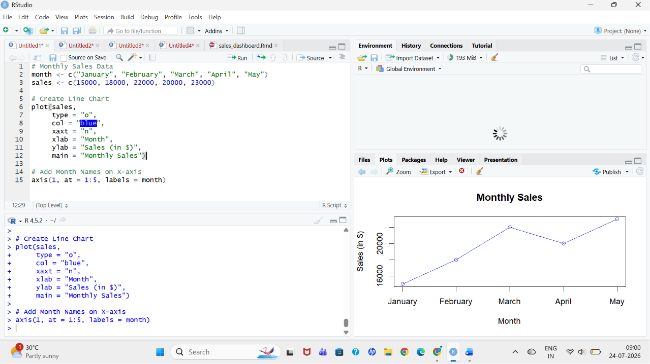
2. Bar Chart for Top-Selling Products: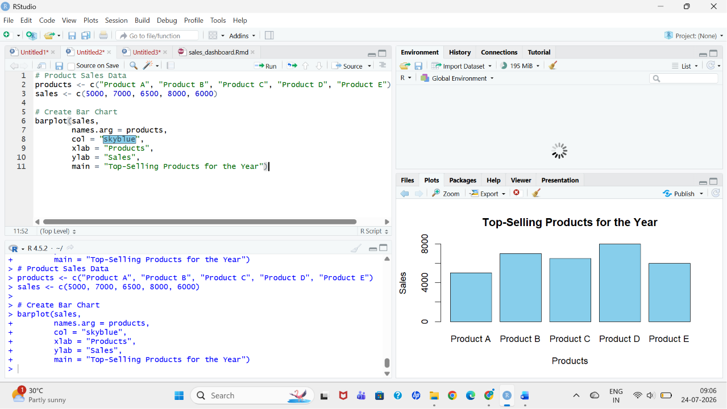

3. Scatter Plot (Advertising Budget vs Monthly Sales):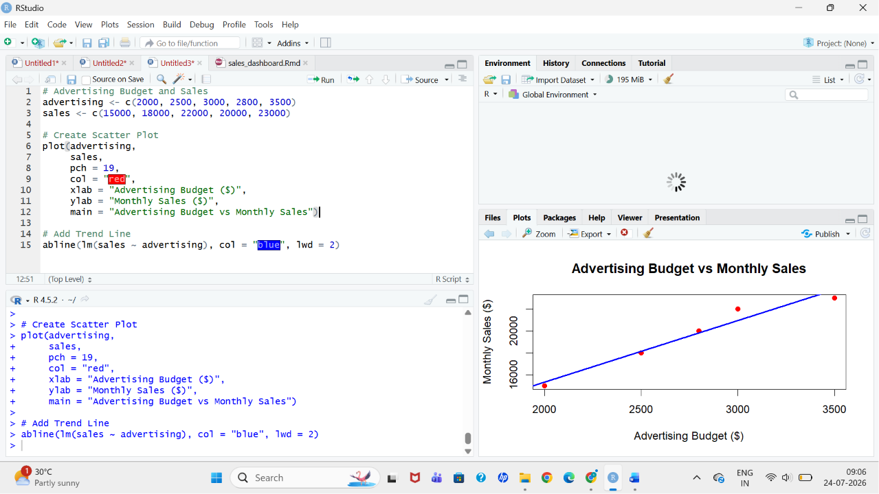
4. Interactive Dashboard (Line Chart + Bar Chart):
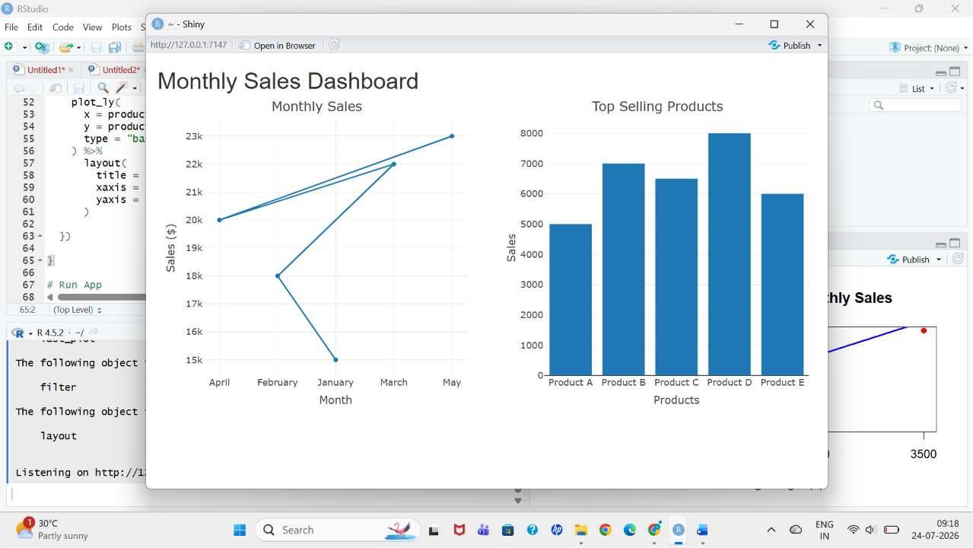

Set 2:
1. Histogram for Customer Ages: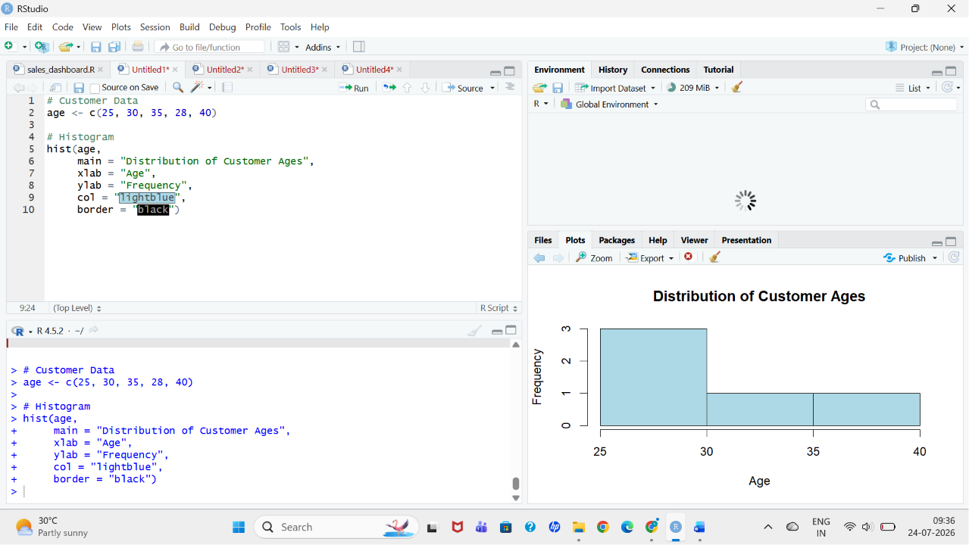

2. Pie Chart for Customer Satisfaction Scores: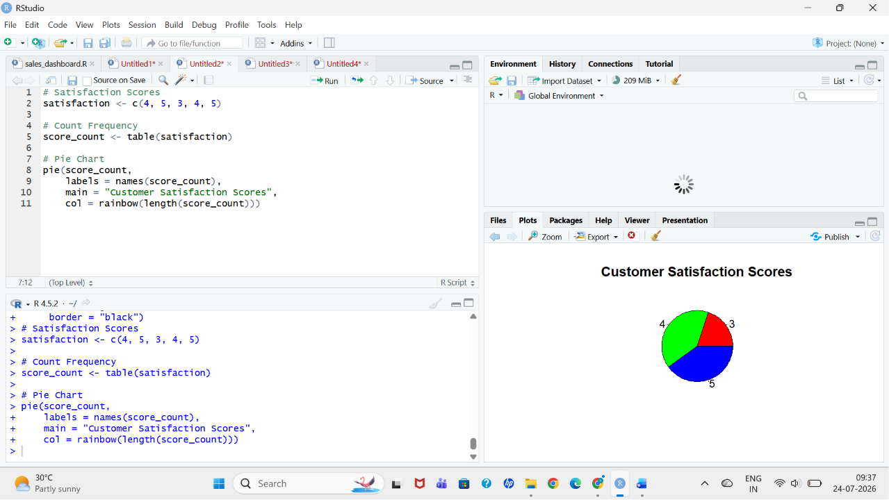

3. Stacked Bar Chart for Satisfaction by Age Group: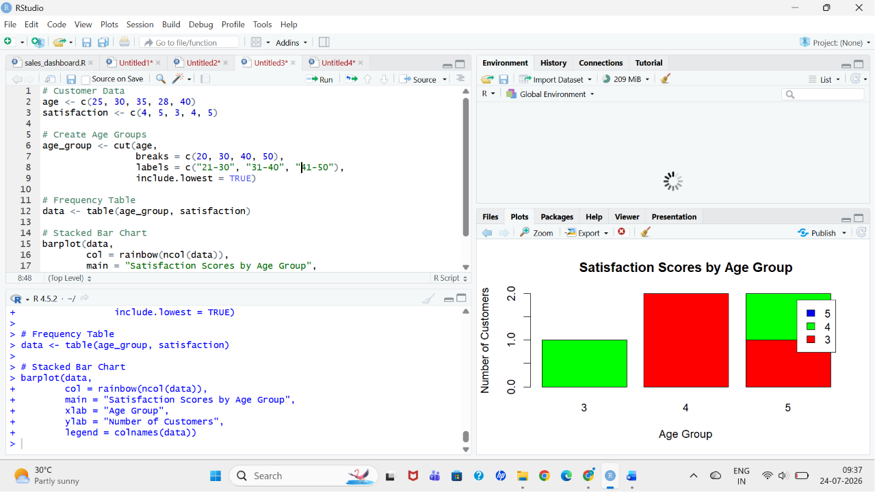
4. Word Cloud for Customer Feedback:

library(tm)
library(wordcloud)

# Customer Feedback
feedback <- c(
"Excellent service",
"Very satisfied with product",
"Average experience",
"Good customer support",
"Excellent quality and service"
)

# Create Corpus
corpus <- Corpus(VectorSource(feedback))

# Convert to lowercase
corpus <- tm_map(corpus, content_transformer(tolower))

# Remove punctuation
corpus <- tm_map(corpus, removePunctuation)

# Remove common words
corpus <- tm_map(corpus, removeWords, stopwords("english"))

# Create Word Cloud
wordcloud(corpus,
max.words = 20,
colors = rainbow(10))

Set 3:
1. Line Chart – Employee Performance Trend: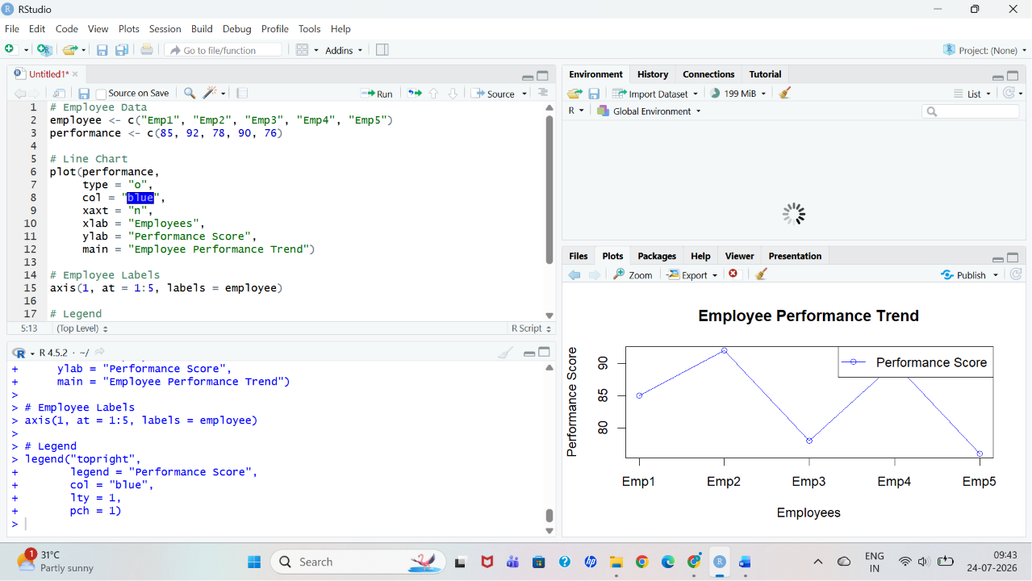

2. Bar Chart – Employees by Department: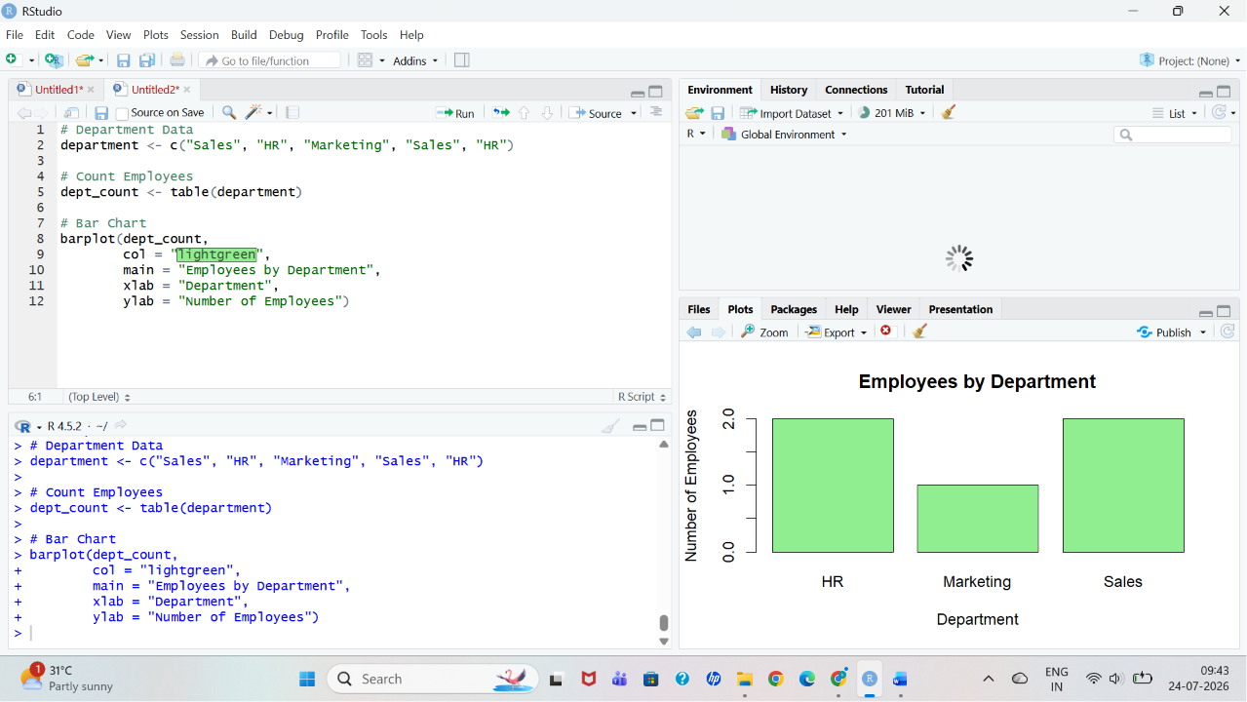
3. Scatter Plot – Years of Service vs Performance Score: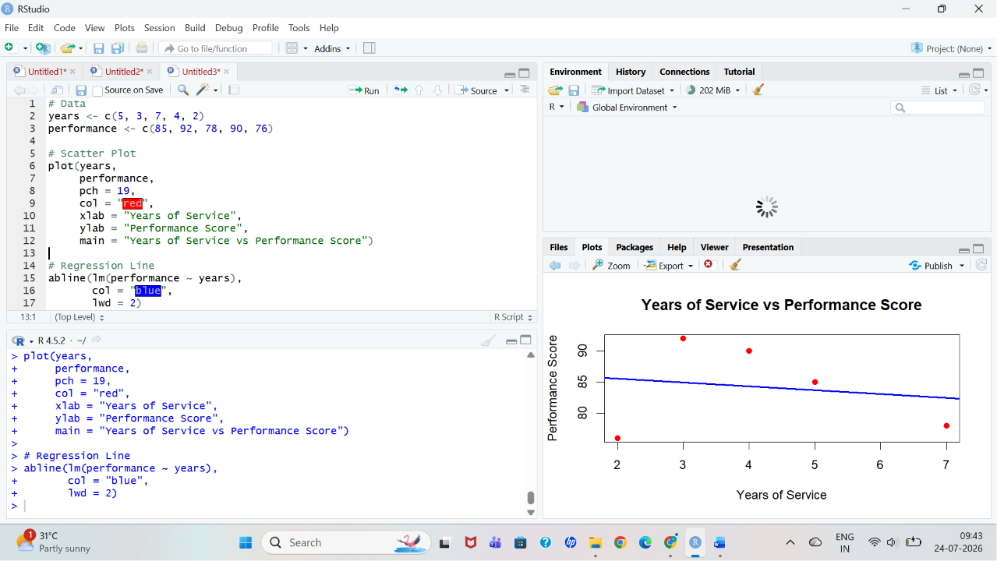

4. Interactive Dashboard (Shiny):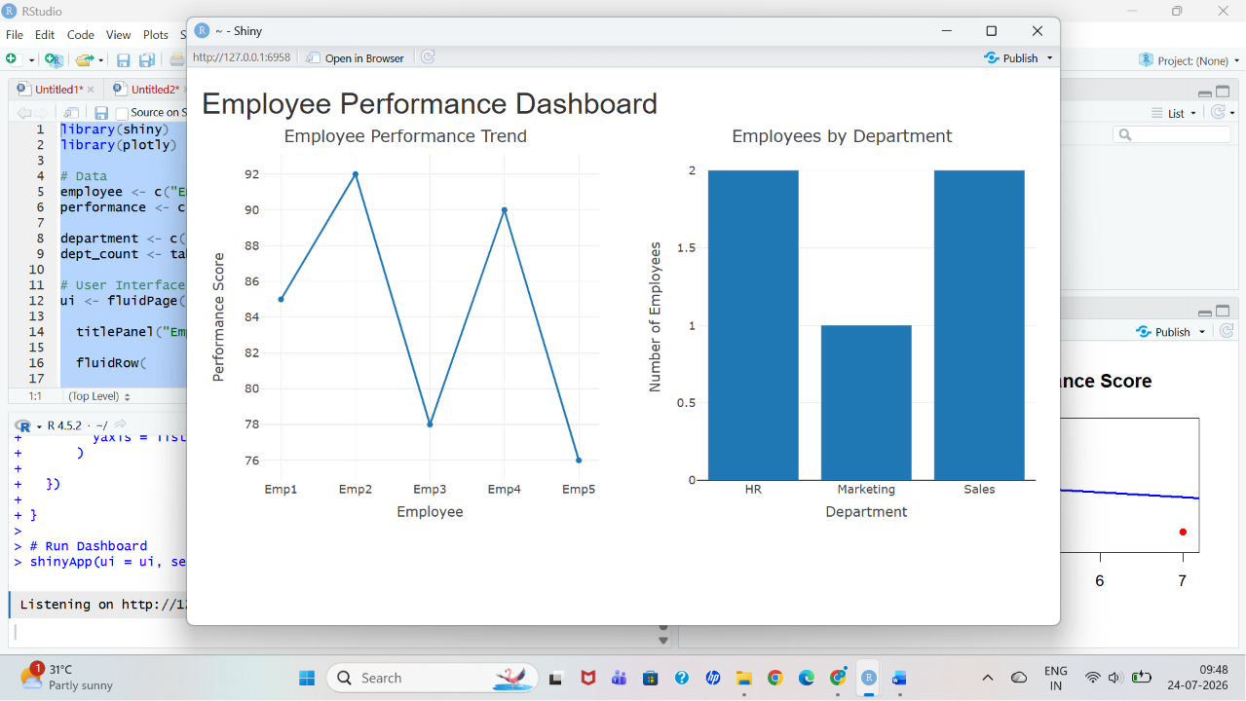

Set 4:
1: Bar Chart: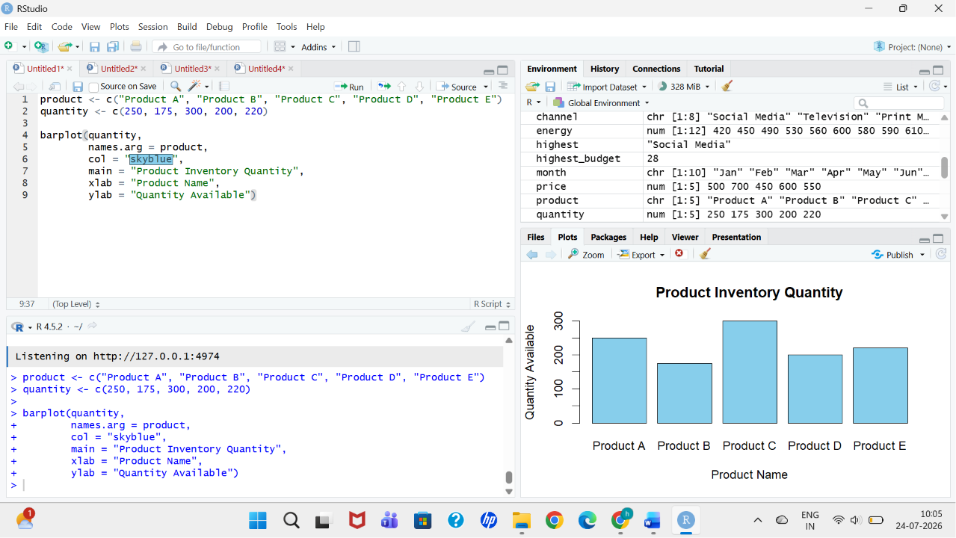

2: Stacked Bar Chart:
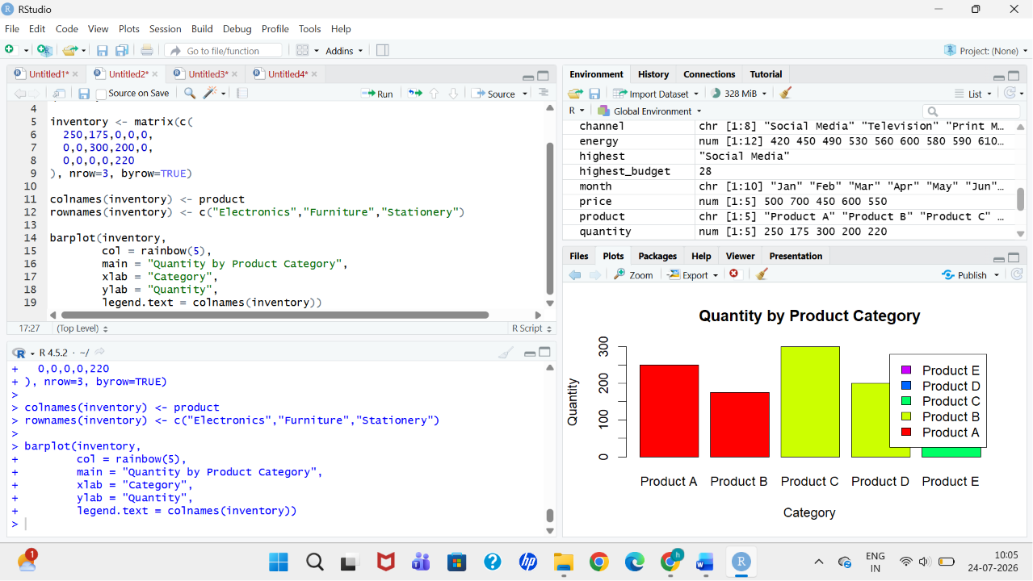
3: Scatter Plot: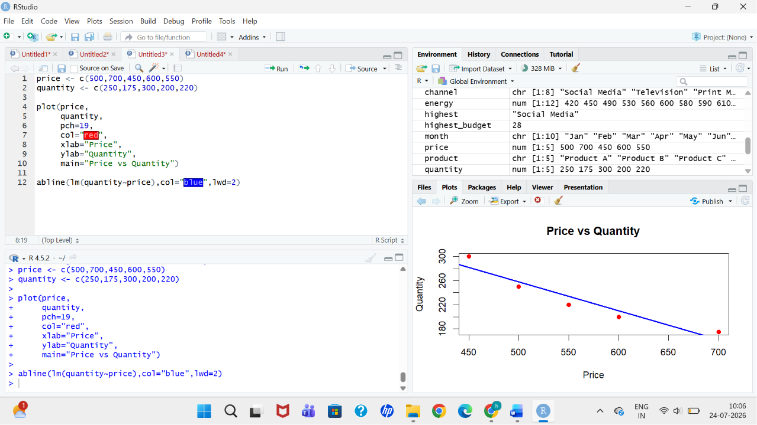

4: Tableau Dashboard: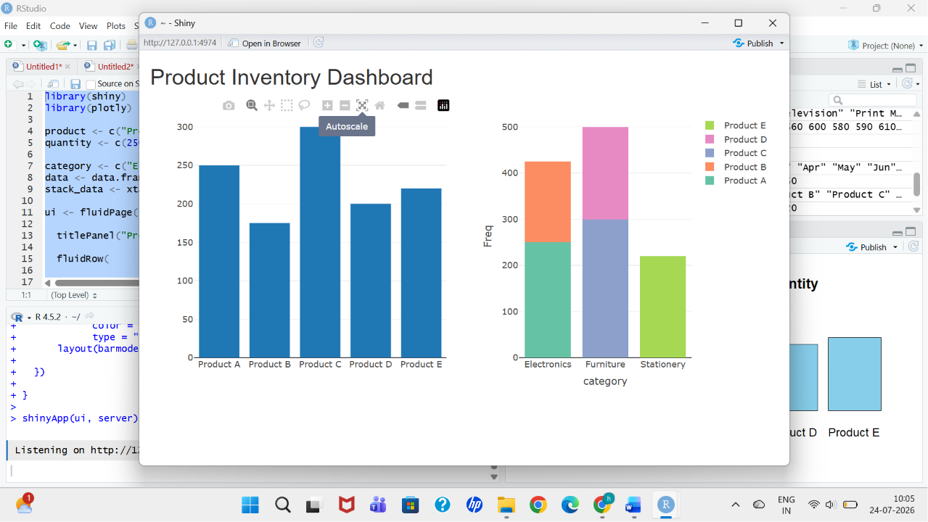

Set 5:
1: Line Chart (Daily Page Views):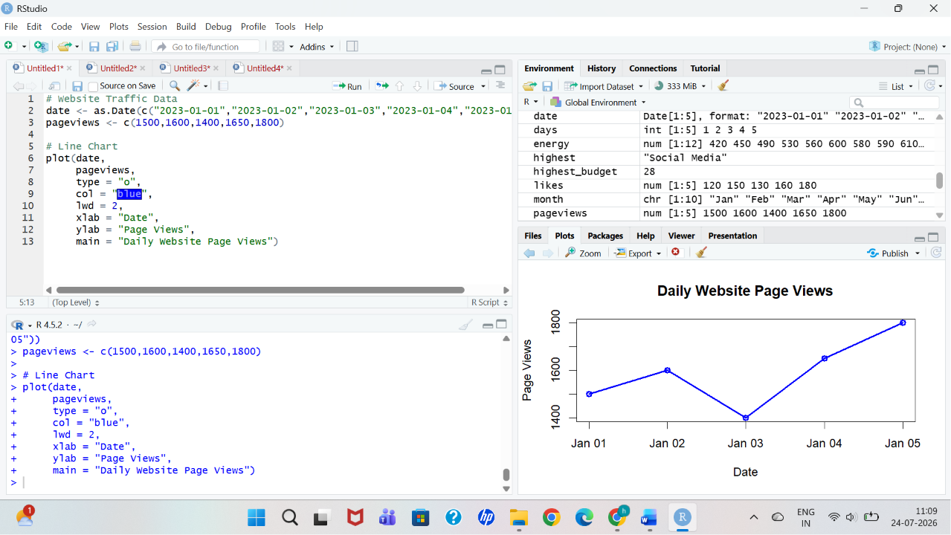

2: Bar Chart (Top Click-through Rates):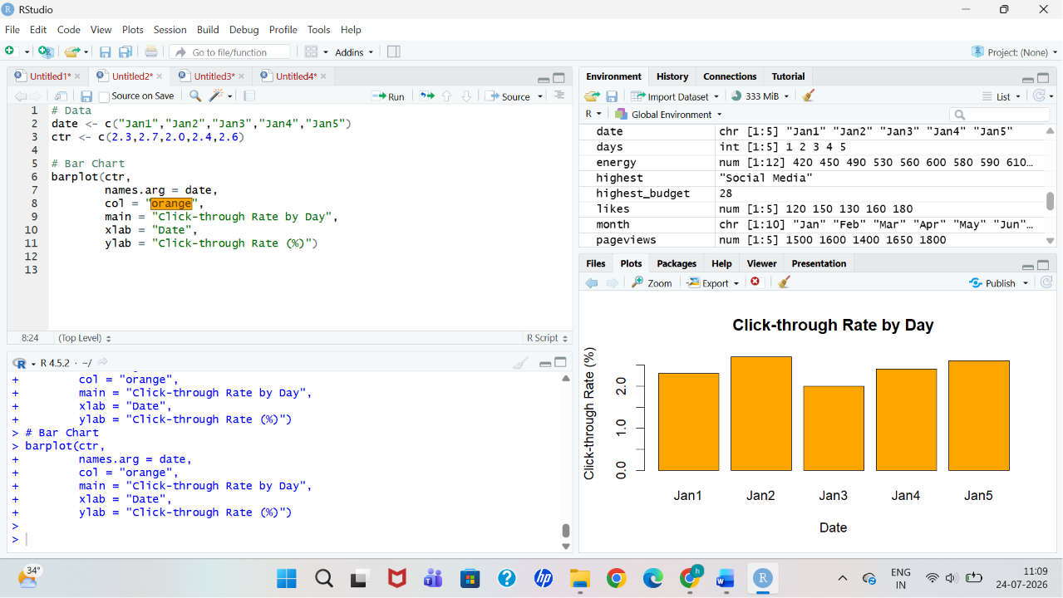

3: Stacked Area Chart (Likes, Shares, Comments):
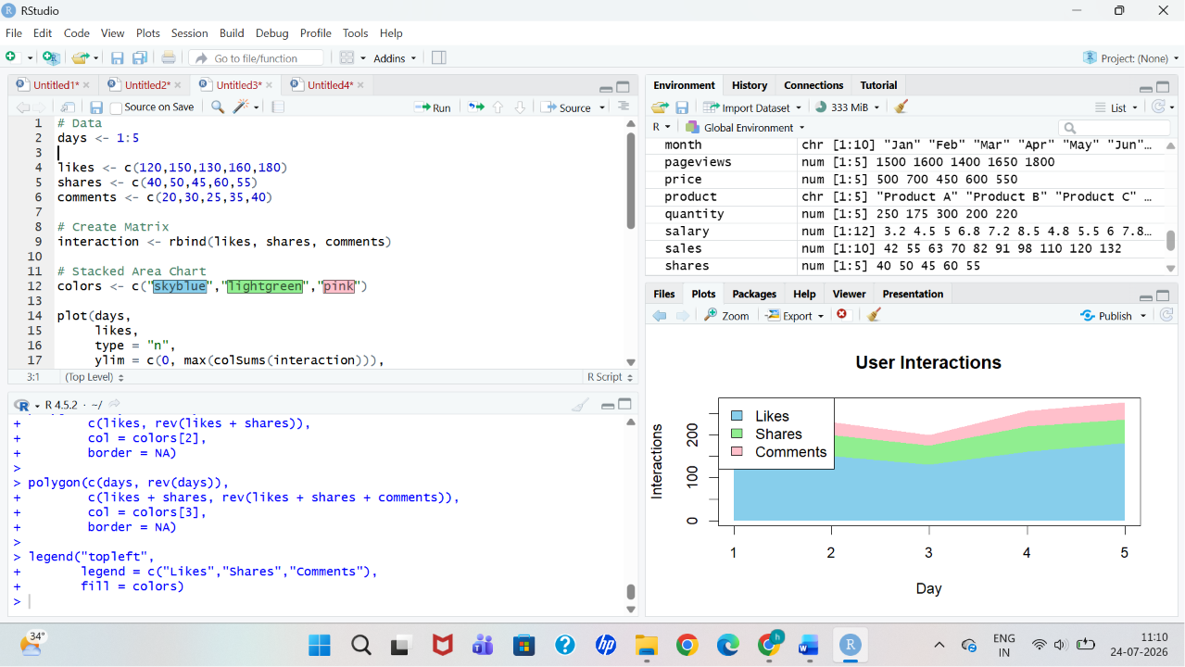

4: Interactive Dashboard (Shiny):